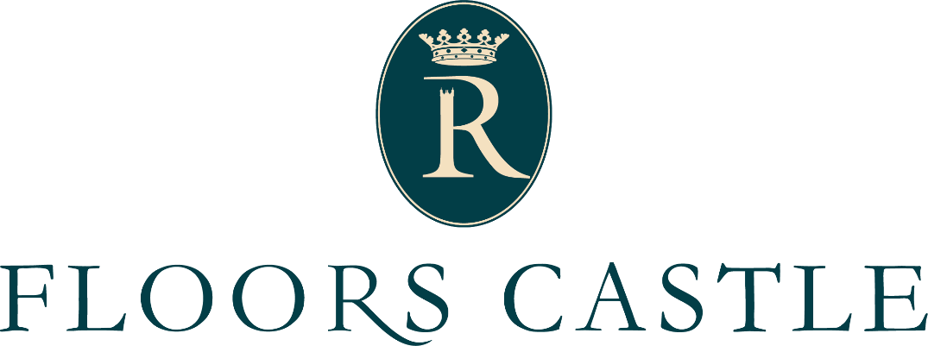

Job Description
An exciting opportunity has arisen to be a part of the seasonal Visitor Support Team at Floors Castle, one of Scotland’s most iconic country houses. We are looking for an outgoing, confident and flexible person to fill a seasonal position, primarily working in the visitor engagement aspects of our award-winning business and helping to present Floors Castle to visitors.
For more information, or to apply for this role, please send a CV and covering letter, detailing your suitability for the role to hr@floorscastle.com
ACCOUNTABLE TO: Operations Assistant
JOB SUMMARY:
- To be a presence in the public rooms of Floors castle, welcoming visitors and answering questions. Ensure excellent visitor care, information provision and product presentation. To conduct guided tours of group visitors.
- To work across the site at need, in retail, admissions, events and visitor engagement. Full training will be provided.
- To help promote upselling and promotion of all products (including Annual Pass & Guide Book) events & activities.
- To provide a high standard of customer service at all times, engaging with customers, sharing knowledge and information about all areas of Floors Castle.
- To be an excellent team player, contributing to the continuous development of the department as part of the visitor welcome team specifically and the Floors Castle team as a whole.
- To contribute innovative ideas to enhance the visitor experience.
- To ensure all standards and expectations are met to ensure our 5* Visit Scotland rating is maintained.
The post involves working weekends and Bank Holidays, providing cover for holiday and at short notice for sickness absence. Attendance at meetings and training days will be required in addition to normal working days.
Situations may arise that require the post holder to carry out other duties, commensurate with their level of responsibility, that involve working in other areas within the enterprises team.

Key Result Areas:
1. Customer Care
· Provide the highest quality of service and demonstrate enthusiasm for the role.
· Ensure all visitors are greeted warmly and promptly.
· Ensure awareness of coach visits, corporate events and other events and necessary planning is in
place to ensure best possible experience for all visitors.

· Respond swiftly, efficiently and appropriately to any visitor comments or queries.
· Be prepared to ‘go the extra mile’ in providing visitors with a memorable and enjoyable experience.
2. Cash Handling & Security
. Check all transactions: cash, cheque, credit card and vouchers.
· Follow cash handling, cashing up and reconciliation procedures accurately
· Always ensure the security of cash and stocks is not compromised.
3. Health & Safety
· Appropriately report accidents, if they should happen, to the duty manager.
· Ensure you are aware of health & safety policy, risk assessments and emergency procedures.
4. Any Other Duties
· Undertake any other duties as may reasonably be requested by Operations manager.
· Attend training courses as required to meet the requirements of the post.
· Be prepared for lone working on occasions and to take responsibility in the Managers/supervisor’s
absence. This may involve opening and closing the castle.

Knowledge, Skills and Experience
Knowledge:
· Must be capable of conversing with a wide variety of people and personalities.
· Must be interested in learning about the property and the surrounding area.
Skills:
· Good communication skills required.
· Demonstrable influencing and selling skills.
· Must have a flexible approach and be prepared to work in all three primary areas of the visitor
support team (in admissions, retail, and in the historic house).

· Must be an approachable and customer focused personality.
· Demonstrate strong interpersonal skills, flexibility and initiative.
· Must work well as a part of a team.
· Must be prepared to learn new information, and impart this to visitors in an accurate and engaging
manner.

Experience:
· Experience in similar operation would be of benefit.
· Cash handling experience.
· Must have experience of working with the general public.
· Proven ability to follow instructions and work on your own initiative.
If you are passionate about excellent customer service, keen to learn more about the fascinating history of the Scottish Borders, and interested in joining our team, then we want to hear from you. Roles available from 1st May to the end of September.
For more information, or to apply for this role, please send a CV and covering letter, detailing your suitability for the role to hr@floorscastle.com
Job Types: Zero hours, Part-time, Fixed Term
Contract length: 5 months
Salary: Up to £11.44 per hour

Benefits:
- Discounted or free food
- Employee discount
- On – site free parking

Schedule:
- Holidays
- Monday to Friday
- Weekend availability
- Customer Service: 1 year (preferred)

